

**Majan College (University College)**

**Department of Information Technology**

Design and Implementation of Money Sharing Web Application

# **Chapter 1: Introduction**

The project being developed in this report is about a money sharing application designed on the concept of ‘Merry go round” scheme and social organization. In this scheme a committee of social members contribute a fixed insubstantial amount of money on a monthly basis. As money is accumulated there is a random draw where a member is selected who will receive all the accumulated money on that particular month, the scheme goes on until all of the members have equally been selected for the payout. The scheme cycles through all members ensuring that no one is left out.

This type of schemes are usually done by a tightly knit community or group that is built upon trust. The history of this money dates from 1960’s where the sharing scheme usually stems from poor rural areas of the region where the community has a basis of mutual help and relief funding. These practices are widely popular in South East Asian countries as well as African countries.

The scheme is also officially referred to as “Rotating Savings and Credit Association” (ROSCA)

Gatherings can be normal or fixing to regular income cycles in country networks. Every part contributes a similar sum at each gathering, and one part takes the entire total once. Accordingly, every part can get to a bigger aggregate of cash amid the life of the ROSCA, and use it for whatever reason she or he wishes. This strategy for sparing is a famous option in contrast to the dangers of sparing at home, where family and relatives may request access to savings.

The framework further decreases the hazard to individuals since it is time restricted—regularly enduring close to a half year. Every part gets at any rate once the sum gathered. This diminishes the span of the misfortune, should somebody take supports early and not pay back.

Each exchange is seen by each part amid the gatherings. Since no cash must be held inside the gathering, no records must be kept. These qualities make the framework a model of straightforwardness and effortlessness that is all around adjusted to networks with low dimensions of education and powerless frameworks for ensuring aggregate property rights.

Notwithstanding their straightforwardness of structure, ROSCAs remunerate when two key conditions exist, which make them aggressive option budgetary items, even in moderately refined economies:

1. Disappointment of the typical financing business sector to give credit to credit commendable borrowers, frequently because of chance cost, direction, or operational cost
2. Disintegration of purchasing intensity of collected reserve funds over long investment funds skylines in inflationary conditions

# Aim of the Project

Aim of the project is to facilitate this type of money sharing scheme in Oman as it is also a popular form of saving within the Arab communities. The web application will ensure that the saving scheme is rendered faithfully in technological point of view. The application will make it even more convenient for participants to interact and take part in the savings with capabilities of proof and documentation within the application.

# Objectives of the Project

* Develop a web application that renders the ROSCA structure in effect.
* Design a suitable interface
* Develop a prototype for testing purposes
* Ensure the web application fulfills all the requirements gathered from analysis
* Submit documentation of the project

# Scope of the Project

Web application should be according to software development standards and should be safe and secure as it involves exchange of bank information between users. The project will allow users to make it easier to keep track of payments done in the month and it will also allow them to send payments within their devices.

# Problem Definition

These are a few problems that are currently being faced by the saving scheme:

* Most of the time people are not available as they are at work or other obligations. So they are not able to attend these money sharing meetings.
* Sometimes members forget to keep track of money payed or deposited.
* Miscalculations and accidental wrong exchanges of amount.
* Exchanging money through cash is also an outdated method, people these days usually rely on credit cards.
* There is no evidence or proof when exchanging money so people rely on verbal communication.

# **Chapter 2: Literature Review**

Rotatory Savings and Credit Associations (ROSCAs) are a prevalent method of sparing in many countries. In neighborhood speech, they are designated "panels" and are especially prominent among ladies. This procedure is rehashed until everybody in the gathering gets one pooled installment. Record-keeping rehearses among ROSCAs may fluctuate, yet, by and large, record keeping is directed in a casual way. ROSCA gather individuals make a set commitment to a store and one of the individuals from the gathering gets the pool of assets through a draw or shared agreement of the individuals.

The ROSCA depends on a feeling of trust. The guarantee, in the event of a default in commitment installments, is the generosity that exists among its individuals. Be that as it may, negative encounters announced amid individuals' time with ROSCAs incorporate extortion, differences and installment defaults, as indicated by FII 2015 information. Therefore, the suspicion may be that the frequency of defaults, or misrepresentation, for instance, is low.

InterMedia's Financial Inclusion Insights (FII) Pakistan Tracker review report for 2013, uncovered some fascinating bits of knowledge about ROSCA gatherings: 9.3 percent of respondents announced utilizing ROSCAs. Of these, 91 percent affirmed to utilize a month to month cycle. Announced commitments changed from $0.09 to $470.20, with a normal measure of $17.96.

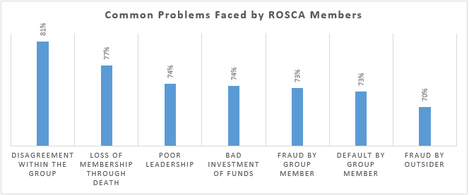

The graph features a portion of the regular issues looked by ROSCA individuals. Understanding these issues requires considering the age-old nature of these exchanges, which, generally, are face to face money exchanges. In light of FII 2015 information, 99.9 % of ROSCA clients reacted in the negative when gotten some information about the utilization of banks or versatile wallets to direct exchanges.

The nonappearance of a budgetary trail leaves these people powerless against different unwanted circumstances. These kinds of issues are normal, and obviously point to the requirement for some money related documentation to check exchanges and enhance straightforwardness. For example, if a ROSCA part professes to have paid his/her commitment to the gathering pioneer, face to face, and the gathering pioneer denies accepting such an installment, at that point, without receipts, there is no chance to get for either to demonstrate their cases.

Utilizing banks to execute is one alternative. The graph below looks at the exertion required to direct ROSCA exchanges with a gathering pioneer versus bank exchanges. It very well may be finished up from these numbers that connecting with ROSCAs through financial balances would be considerably more dangerous contrasted and the present strategy for access, as a bank will in general be more distant away than a ROSCA bunch pioneer. Nonetheless, executing through banks may demonstrate awkward given the exertion required

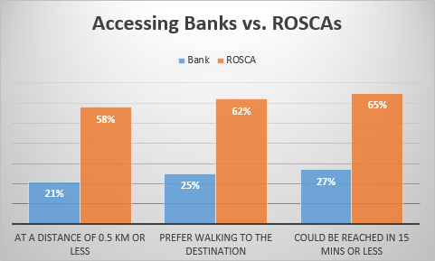

At the point when comfort is figured into the capacity to make these exchanges, portable cash accounts turn into the conspicuous decision. Absence of cell phone possession won't represent an issue in making this change: FII 2015 information indicated 60 % of ROSCA clients had their very own cell phones. In any case, working a portable cash record could turn out to be a repetitive undertaking considering, of the individuals who had a cell phone, 71 % had never sent a SMS, a key factor in deciding a person's potential for utilizing a versatile cash account.

ROSCA clients could turn out to be a feasible market specialty for portable cash suppliers. By encouraging existing money related conduct through portable wallets, an application, for example, "Akiba" can possibly yield various advantages, not the slightest of which is a truly necessary budgetary trail of exchanges. Such applications additionally can possibly empower versatile wallet reception and, subsequently, stretch out money related consideration to the unbanked.

# **Chapter 3: Analysis**

In this section I will talk about the various methods used in order to acquire the needed information for developing the project.

Necessities are the "outlines" that everybody required on the undertaking uses to work from. Poor prerequisites significantly affect the final products of frameworks or ventures. At the point when there are poor necessities, this can prompt poor plans and tests, which thusly will cause delays being developed and testing. Testing is additionally organized to concentrate on what's essential. On the off chance that the prerequisites are imperfect or hazy, testing isn't appropriately executed and will in the long run lead to low quality. The prerequisites must be modified; subsequently, these deferrals add to a late undertaking. Poor item quality can result from poor prerequisites in circumstances where key parts are disregarded and left out altogether. To maintain a strategic distance from poor prerequisites, it is exceedingly imperative that the investigation period of the SDLC is altogether finished, without being neglected.

# **Problem Definition:**

* There is no system or guidance in place to promote saving
* Spending outweighs saving
* Unable to precisely track spending
* Money sharing scheme is popular in the community but there are no regulations
* Trust between each member is the only way to make the scheme successful

Analysis was done with the following methods:

* Interviews
* Questionnaires
* Observation

From the interviews, some of the following questions were presented in order to find out the general consensus regarding the matter:

1. What are the key problems when saving money?
2. Why is the money sharing scheme convenient?
3. Why are bank loans discouraged within the community?
4. Will the use technology in savings help the general populace?

## Results:

General answers obtained from the questionnaires included:

* People generally have problems when spending at once
* They are umable to keep track of spendings
* The money sharing scheme is convenient because it distributes money equally and people who are in critical need of it can take advantage
* Bank loans are generally discouraged because paying out loans is increasingly difficult especially if there is interest involved
* People are willing to accept new technology but are reluctant in using complicated steps and it is difficult to trust reliability of a new system.

## Feasibility Study

Feasibility study is required to ensure that the project being developed is within Technical and Financial boundaries.

## Technical Feasibility

Technical Feasibility is performed on the basis of whether the system is capable to be developed

with the current technologies available. Android studio and MySQL database would be used which is readily available. Development will be done on University provided PCs or Personal Laptops. Hardware implementation can be done on any android smartphone device with version 7.0 and above.

## Financial Feasibility

Financial Feasibility is concerned with how the project can be completed while minimizing costs during development. Android studio SDK is free to use and Publishing it in the google play store is free as well. There will be apple store publication fees so the web application will be available on google store initially.

# **Requirement Analysis**

To fulfill the system requirements the following functions have been recognized as necessary for the system to be recognized as functional.

* System should enable user to transfer and receive payment through the web application.
* System should keep track of all the transactions made.
* System should enable users to contact each other
* Admin must have privileges which other users cannot access
* Notification system should be in place as reminders
* Payment and Receivable transactions should be secure.

# **Requirement Specification**

In this section the functional and non-functional requirements will be listed which will match the needs of the problems that were defined from the analysis phase. The web application will have 2 versions. One for the general users and the other for the admin who will manage the operation of the application.

## User Functional Requirements:

* **Log in/out function**

User should be able to log in and out of the system.

* **Profile page**

The profile page will act as a dashboard for the user and will have all main functionalities such as he will be able to save his bank details and other information.

* **Receive Payment**

This function will allow users to receive incoming payments

* **Transfer Payment**

This function allows users to transfer specific payments from their account

* **Payable Amount**

This page will display the amount which the user has to pay

* **Calendar System**

This will allow users to keep track of the payments or receivables

* **Notification System**

Users should be notified when a payment is due or if there is incoming receivable

* **Voice and Chat System**

Users will be able to communicate with other members through voice or text

* **Payment Gateway**

Users will be able to select their preferred payment gateway

## Admin Functional Requirements:

Admin will have all the functionalities listed in the user section above and will include additional functionalities such as:

* **Add/Delete/Modify Members**

Admin will have control on member registration.

* **Settings**

This page will allow the admin to change core settings of the app like date and time format, currency.

* **Reporting**

Admin can create daily, monthly or annual reports to keep track of exchanges

## Non-Functional Requirements:

* **Performance**

The web application should utilize standard memory resources and maintain minimum allocation of space.

* **Security**

It should be secure as there are bank information involved

* **Design**

It should be designed in accordance with UX standards to allow for ease of navigation and user friendliness

* **Adaptability**

The software should be easily modifiable in situations where changing an attribute or value would be required.

# **Chapter 4: Design**

The Design Phase looks to create itemized particulars that underscore the physical answer for the client's data innovation needs. The framework necessities and legitimate portrayal of the elements, connections, and properties of the information that were recorded amid the Requirements Analysis Phase are additionally refined and apportioned into framework and database plan details that are sorted out in a path appropriate for usage inside the imperatives of a physical situation.

Amid the Design Phase, the underlying procedure for any essential preparing is likewise started. Evaluations of venture costs are refreshed to reflect real expenses and gauges for future stages. What's more, the work anticipated future stages is reclassified, if important, in view of data obtained amid the Design Phase. A formal survey of the abnormal state engineering configuration is directed before point by point structure of the robotized framework/application to accomplish certainty that the plan fulfills the framework prerequisites, is in conformance with the venture engineering and recommended structure guidelines, to raise and resolve any basic specialized as well as task related issues, and to distinguish and alleviate venture, specialized, security, and additionally business dangers influencing proceeded itemized plan and consequent lifecycle exercises.

**User side design**

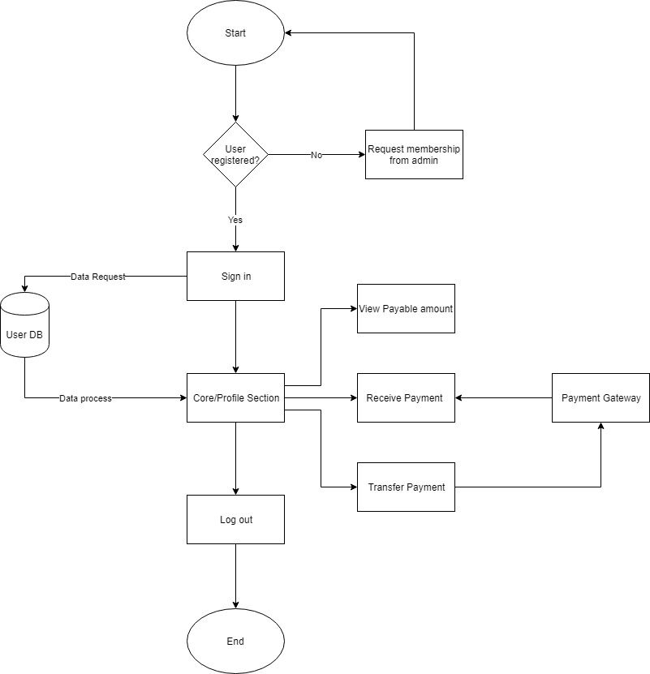

The figure shows the initial design of the user side application. The user starts with signing up, only the admin has the functionality to register a user so the user must request membership from admin to use the application. After signing in the user will then be presented with the profile page. From there the user can perform the exchange functionalities including the transfer and receive functions. User will also be able to select the payment gateway they want.

**Admin side design:**

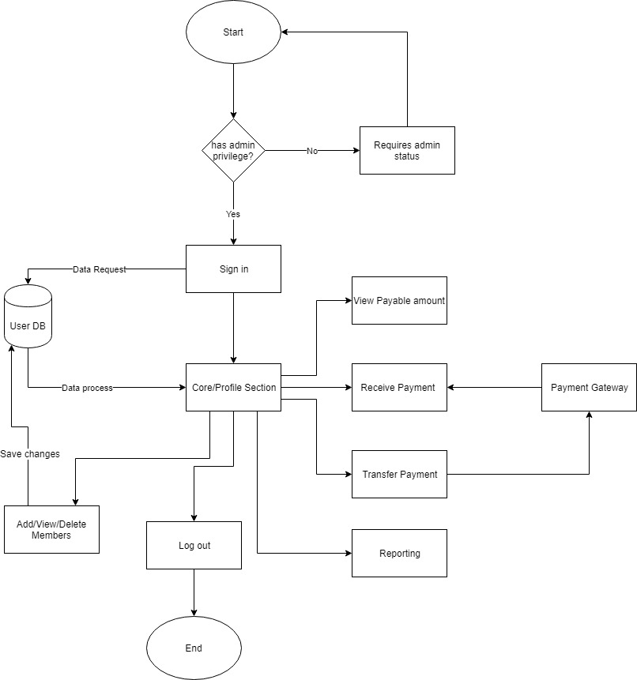

The admin side will have all the functionalities included in the user side with additional functions such as modifying current users as well as being able to add or delete the others. The admin will also have the capability to create reports of transactions between users so as to track them on a daily, monthly and yearly basis.

**Use Case Diagram:**

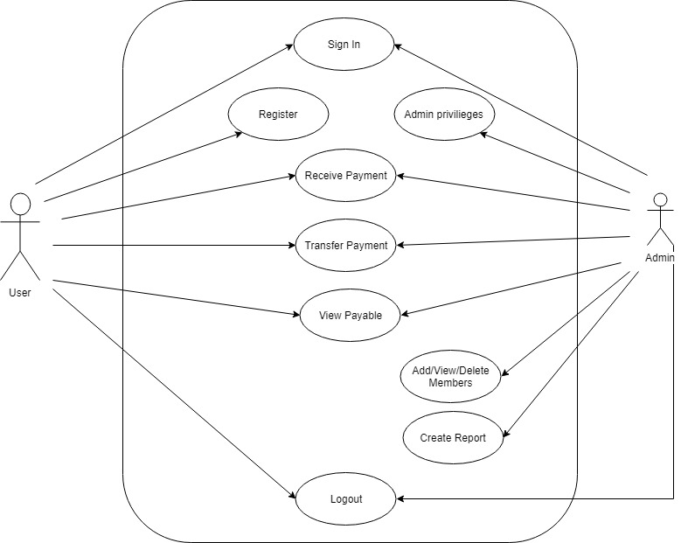

The use case diagram displays the basic functionalities that the two type of accounts are able to perform. The main functionality being to send and receive payments. However as discussed in the functional requirements the admin will posses the functionality to modify and add new members. The application is designed in such a way as to promote community standards where user will appoint a leader in operating the whole system and overseeing transactions done to ensure that everyone involved receives fair and equal chances when using the web application. The application’s important function to create reports is reserved for the admin.

**User Interface Design:**

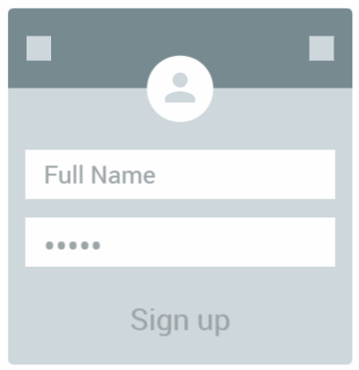

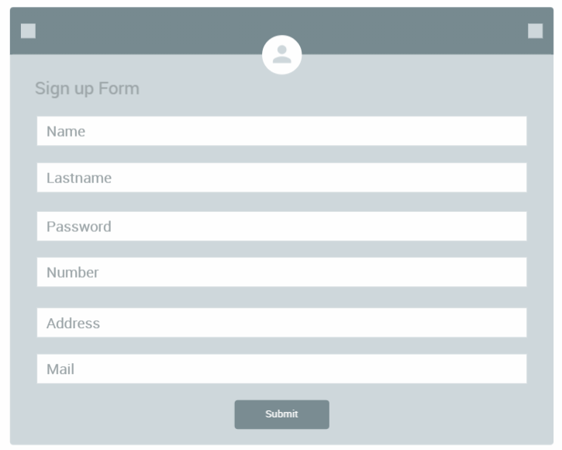

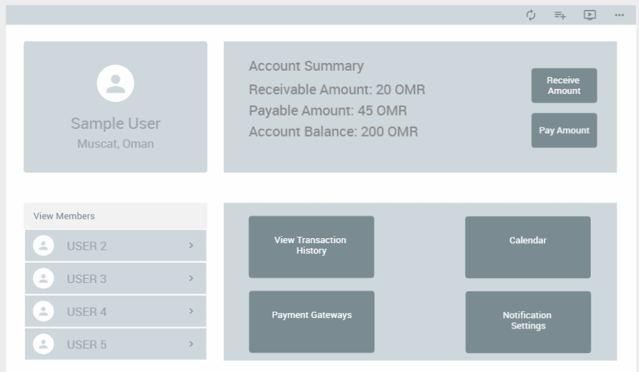

# **Chapter 5: Implementation**

In the Implementation Phase, the computerized framework/application or other IT arrangement is moved from advancement status to creation status. The procedure of execution is reliant on the qualities of the venture and the IT arrangement, and consequently might be synonymous with establishment, organization, rollout, or go-live. From a framework security point of view, the last framework must be guaranteed and authorize for use in the creation condition amid the Implementation Phase. On the off chance that important, information transformation, staged usage, and preparing for utilizing, working, and keeping up the framework are practiced amid the Implementation Phase. The Implementation Phase closes with a formal choice to discharge the last IT arrangement into the Operations and Maintenance Phase.

## Agile Model:

The Agile model enables groups to recognize and address issues on undertakings before they advance into progressively critical issues, and draw in business partners and get their input all through the improvement procedure.

The Agile model has been around for a long time in programming lifecycle models. Be that as it may, of late, it has turned into a noteworthy main step to step model behind programming improvement in numerous associations.

The methodology produces progressing executable cycles, each highlighting, gradual changes from the past executables. A few organizations esteem the agile strategy so much that they are currently applying it to different kinds of activities, including non-tech activities.

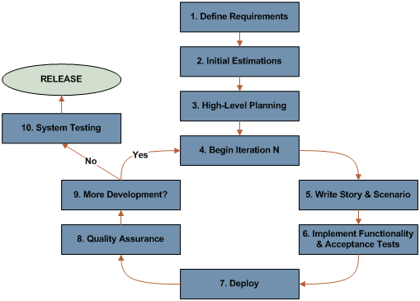

Agile Model Diagram

## Database Model:

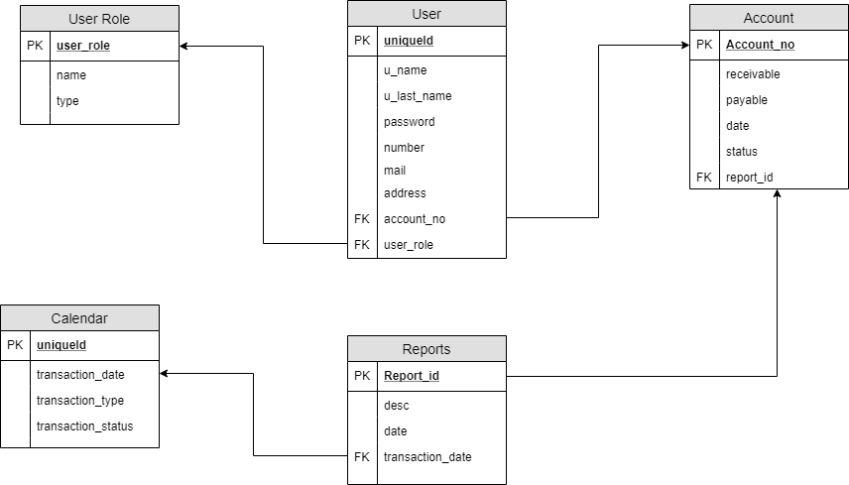

The database model shows the core function of money transaction between users. The account type is authenticated via user login and the roles are assigned as it is redirected from the database. The payment gateway will automatically process bank transactions as well as allowing users to select their preferred service in terms of the payment or reception. The database will be created using MySQL and design will be created using MySQL Workbench.

## Gantt chart:

The Gantt chart displayed below shows the schedule and plan of the project throughout the development lifecycle process. The start and end dates have also been included on all various phases of the project.

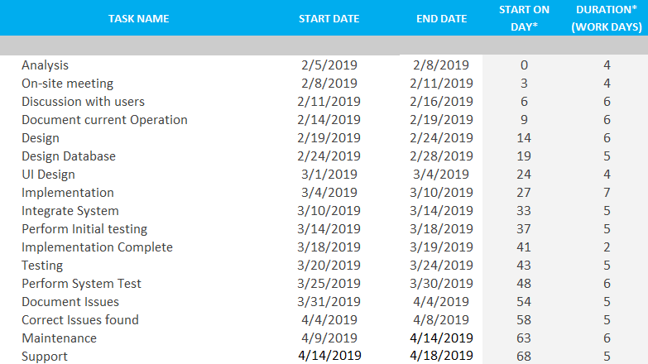

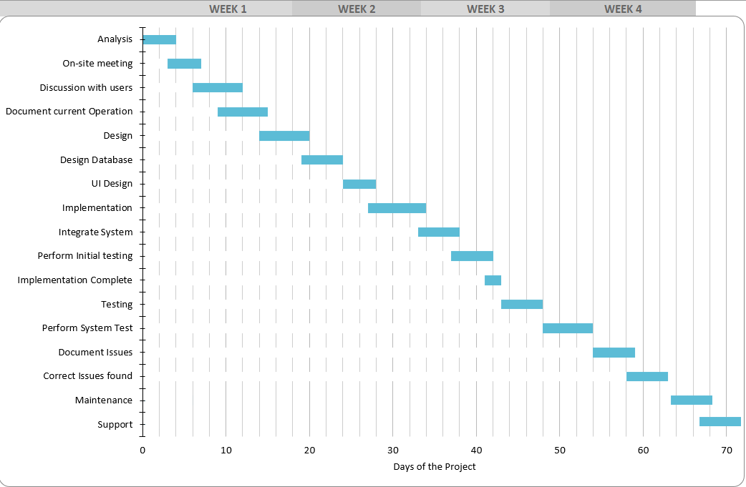

# **Chapter 6: Testing**

The target of the test is to check that the usefulness of the web application works as indicated by the specifications. The test will execute and confirm the test contents, recognize, settle and retest. A lot of stable test contents that can be reused for Functional and test execution

Black Box testing will be implemented to make sure all of the given output produces the expected and desired output as the web application has been programmed to perform.

* Testing will be centered around meeting the business destinations, cost proficiency, and quality.
* Testing exercises will expand upon past stages to stay away from excess or duplication of effort.
* Testing will be a repeatable, quantifiable, and quantifiable activity.
* There will be normal, steady strategies for all groups supporting testing exercises.
* Testing will be separated into unmistakable stages, each with plainly characterized targets and goals.

Testing will be performed once the system development has been completed

# **Chapter 7: Conclusions & Recommendations**

To conclude this report, the main aim as discussed above is to develop an application which emulates the money sharing scheme called “Rotating Savings and Credit Association” (ROSCA)

The money sharing helps various types of user that rely on community savings to afford a healthy lifestyle. This form of money sharing always had specific problems as described above mainly due to the inability to keep track of payments and the inconvenience of sending or receiving cash in person.

The web application aims to eliminate these problems by providing a cost-efficient way in sending and receiving payments. This web application also enables the user to track payments with a few clicks hence helping them through reminders and notifications of the web application.

As discussed in various chapters of the report the system was developed using agile method as a means to eliminate any errors or confusions in a specific phase. The development model enabled iterative type of development which also factors in risk assessment so to avoid any discrepancies before moving on to the next step.

Within the report the development schedule was also shown which depicts the approximate time it will take the project to be completed factoring in all the necessary phases to develop a functional application. The functional and Non-Functional requirements were also highlighted in the report, which will be used as the foundation of developing the web application in regards to the problem scope discussed before it.

Further recommendations and enhancements for the application will be applied once user feedback has been received, the web application is also intended to have a social feature which allows user to communicate and share various information. As well as increasing optimization and security for making the web application a reliable and secure means of sending and receiving money transactions.

# **References:**

* Softwaretestinghelp.com. (2018). [online] Available at: https://www.softwaretestinghelp.com/wp-content/qa/uploads/2014/02/Live_Project_Test_Plan_SoftwareTestingHelp.pdf [Accessed 15 Dec. 2018].
* Moneyadviceservice.org.uk. (2018). *Rotating Savings and Credit Associations*. [online] Available at: https://www.moneyadviceservice.org.uk/en/articles/rotating-savings-and-credit-associations [Accessed 15 Dec. 2018].
* People.scs.carleton.ca. (2018). [online] Available at: http://people.scs.carleton.ca/~jeanpier/3004F18/T2-%20Intro%20to%20Agile%20Development/extra%20material%20on%20Agile%20Methods/The%20Agile%20System%20Development%20Life%20Cycle%20(SDLC).pdf [Accessed 15 Dec. 2018].
* www.tutorialspoint.com. (2018). *SDLC Agile Model*. [online] Available at: https://www.tutorialspoint.com/sdlc/sdlc_agile_model.htm [Accessed 15 Dec. 2018].
* TechCrunch. (2018). *Yahoo Finance launches social savings app Tanda, an alternative to credit cards*. [online] Available at: https://techcrunch.com/2018/01/19/yahoo-finance-launches-social-savings-app-tanda-an-alternative-to-credit-cards/ [Accessed 15 Dec. 2018].
* Rotating Saving Groups » Collaborative Finance. 2018. *Rotating Saving Groups » Collaborative Finance*. [ONLINE] Available at: <http://www.collaborativefinance.org/rosca/social-saving/>. [Accessed 15 December 2018].
* Coursera. 2018. *Web Application Development with JavaScript and MongoDB | Coursera*. [ONLINE] Available at: <https://www.coursera.org/learn/web-application-development>. [Accessed 15 December 2018].