Requirements
You build a price comparison website that displays products and their prices from several different websites. (Netbeans IDE)
• The user can search for products on the website.
• Shopping functionality and customer registration/login are not required.
• Your website provides links that enable users to navigate to the product on the original website.
• You can propose a different type of project based on scraped data from multiple websites - for example a property search website.
• Website scraping must be done using Java.
• You must use a SQL database to store your data. MySQL/MAMP/HeidiSQL/MariaDB
• Several threads should be used to download data.
• Use Spring, Hibernate and Maven.
• The back end of the website must be implemented in JavaScript running on Node.js. No marks are available for functionality that is implemented in other programming languages.
• Your application includes a REST API. This can be integrated into your front end (via AJAX). Or it can be a separate web service that enables third parties to access your data.
• . You cannot write an app.

- Project report.
This must include:
• Screenshots showing all of the website’s key functionality.
• Description of the website. You should explain the web scraping, the RESTful web service and how the JavaScript displays the data.
• Diagram showing the final database design.
• Documentation of the tests.

- Source code.
Your source code zip file should contain the following files:
• Maven build file (pom.xml).
• Spring configuration file(s) (beans.xml). Not needed if you are using annotations.
• Hibernate configuration file(s).
• Java source code for web scraping.
• Java source code for unit tests.
• Java API documentation.
• Node.js JavaScript source code.
• JavaScript source code for unit tests.
• Front end source code for website (JavaScript, HTML, CSS).
• Other source files for website, for example. Vue files etc.
- Database dump:
• Back up your database using mysqldump (or a similar tool if you are not using a MySQL database).

Threads. Use of multiple threads to pull data from several websites.
Maven. Use of Maven to build Java software.
Spring. Use of Spring to manage the dependencies between several Java classes.
Hibernate. Use of Hibernate to store data in database.
Web scraping. Download of data from third party websites using JSoup or similar tool. You must use Java for web scraping
Data. You must use a SQL database. Higher marks are awarded for projects that have more data, more complex tables, efficient data storage, clean data and sensible SQL naming conventions.
Testing. Marks for tests will only be awarded if the source code is submitted and screenshots of the results are included in the final report. You must test the functionality of your code. Zero marks will be awarded for trivial tests, such as tests of getters and setters. All tests must be passed.
REST API. Implemented in Node.js.

Product display. User can search for products and compare product prices from multiple websites. Pagination is used when there are a large number of products.
Website quality. How well does it display data, allow user to interact with data etc.
Code quality. For example, comments, layout, organization, etc.
Project report. Briefly describes the project.

Price Comparison Website: PowerBankNo1
Project Proposal

Table of Contents
Introduction 2
Sketches of the PowerBankNo1 website 2
Websites and URLs 4
Diagram of the database design 5

Introduction
The reason portable chargers exist is that the applications of the portative device are used by many people. The smartphones, tablets and laptops are something that is needed to connect with others or use them as a source of entertainment. They even involved in our working life.
It is about halfway through the day in certain moments that the smartphone's battery can be found at almost 0 %. The time when the panic starts: the smartphone is about to die, and there is no solution to keep the friends messaging, make plans or communicate to the world. Urgently require a power source to load to the life that device. Here a power bank comes in; it will quickly start charging the portable device. Even if the device has nearly 0%, resulting in, it will be used continuously without any interruptions.
One of the key myths that most users have about power banks is that they genuinely think power banks are costly. It is just not accurate at all. Many wearable battery packs are at very affordable prices, even high-quality models.
The proposed price comparison website PowerBankNo1 will be comparing brands of portative battery chargers to find out the best value for the cost. The price comparison website will be not just a website that can get high-quality goods, but it will go to help many users to save money. The users will also be able to see the rating and read reviews about the chosen product from customers who have already bought the same product.

Sketches of the PowerBankNo1 website
Wireframes of the proposed price comparison website PowerBankNo1 have been designed in Microsoft Visio Professional 2016 (Screenshots: Figure 1 and 2).
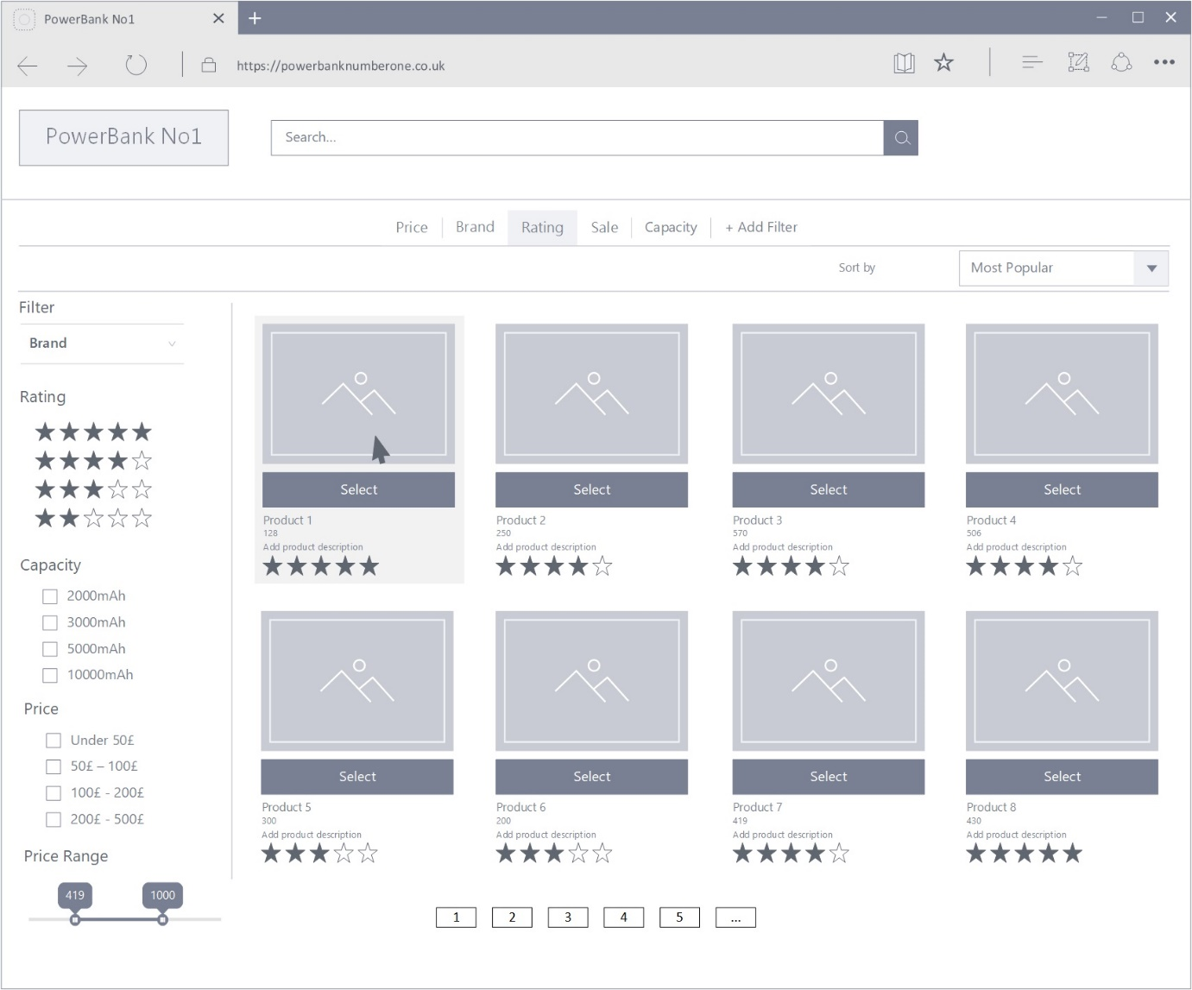
Figure 1. Search the product.
The search bar on the main webpage will help the users find the particular power bank from the drop-down menu. With one click will be open the gallery of recommended products for the best deal and quality. The capacity, price and rating filter bar on the left side of the website page will help narrow down the search (see Figure 1).
Next step, the users choose the desired product. But before the purchase, they will be able to see full descriptions, specifications and most important thing: comparison prices from different retail dealers (see Figure 2).
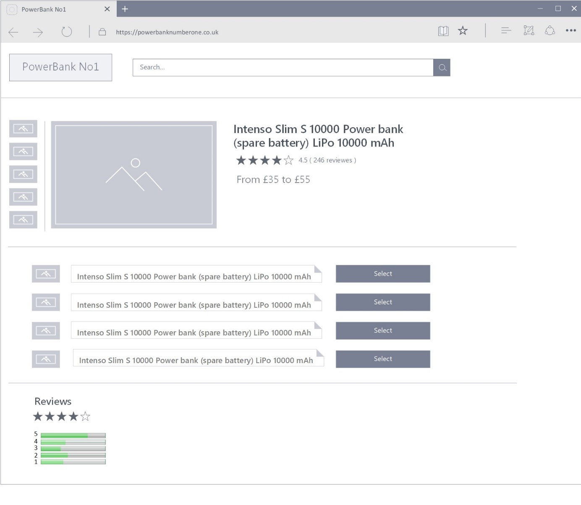
Figure 2. Choose the product.

Websites and URLs
One of the approaches to get prices and information about the searching product is to scrape the website. In this method, the retailer's websites will be scanned for required information. For this purpose have been chosen the following websites and their URLs:
- PC Development Ltd.: https://www.pcdevelopment.co.uk/index.aspx
- UK -computers: https://www.uk-computers.co.uk/home/
- Stuff-uk.net: https://www.stuff-uk.net/home.aspx
- Center Tek: https://www.centertek.co.uk/home/
- IT Supplier: http://it-supplier.co.uk/shop
- Officeworx: http://shop.officeworx.co.uk/
- Laptopsdirect: https://www.laptopsdirect.co.uk/
- Evaris: https://www.evaris.com/shop/
- OnBuy.com: https://www.onbuy.com/gb/
- Mobisun: https://www.mobisun.com/

Diagram of the database design
Diagram of database design for the proposed price comparison website PowerBankNo1 have been designed in Microsoft Visio Professional 2016 (Screenshot: Figure 3).
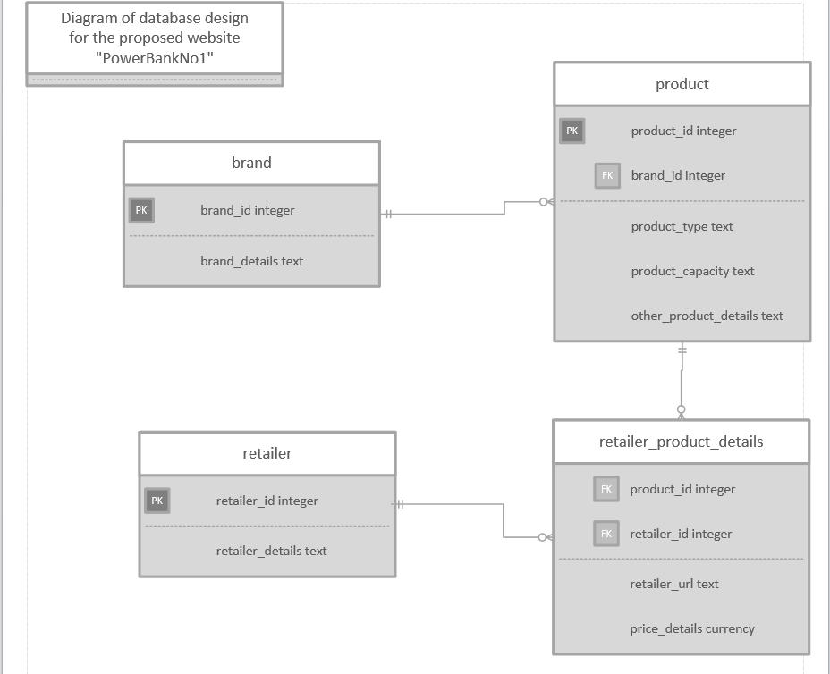
Figure 3. Diagram of database design for the website “PowerBankNo 1.

Feedback from Tutor

